Exploring the Efficiency of Searching for a Specific Item in a Large Online Marketplace Database Using a Linear Search Algorithm

Miles Exner

Colorado State University Global

Course Code: CS506-2

Instructor: Jonathan Vanover

Due Date: 05/19/2024

Exploring the Efficiency of Searching for a Specific Item in a Large Online Marketplace Database Using a Linear Search Algorithm

In the ever-evolving landscape of online marketplaces, efficiently locating a specific item within an extensive database can be challenging. The linear search algorithm, though simple, is particularly suited for certain scenarios. This paper examines the applicability of the linear search algorithm for searching specific items in large databases, analyzes its time complexity, and discusses the relationship between data structures and search performance. Additionally, it considers external factors that influence the efficiency of the linear search algorithm.

# Time Complexity Analysis

The time complexity of linear search is O(n), where n is the number of elements in the dataset (Knuth, 1998). This implies that in the worst-case scenario, the algorithm might need to inspect every item in the database. Considering an extensive online marketplace database, this means performance can degrade linearly with the size of the database.

Heuristic optimization can speed up searches using different strategies, such as placing the last searched item at the front of the list (Zybooks). In an online marketplace, it is important to categorize items. Performing a linear search on marketplace items that are already indexed by specific tags, categories, or other metadata can significantly reduce the list size, making the search faster.

Despite its O(n) time complexity being less efficient compared to algorithms like binary search (O(log n)), its applicability stems from its simplicity and versatility in scenarios where other search algorithms cannot be used due to the unsorted nature of the data (Sedgewick & Wayne, 2011).

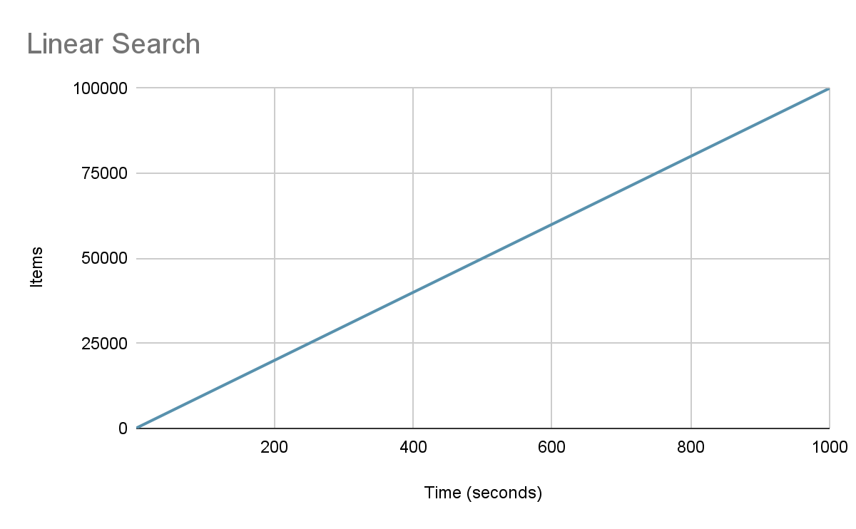

# Impact of Data Structure

The performance of linear search is intrinsically tied to the structure of the data it operates upon. For example:

* **Arrays/Lists:** Linear search works efficiently, offering seamless traversal through each item (Knuth, 1998).
* **Linked Lists:** It performs adequately but slower than arrays due to the lack of indexed access.
* **Hashed Data Structures:** Linear search is generally not recommended since hashed structures enable more efficient search algorithms (Cormen et al., 2009).

# External Factors Influencing Performance

Several external factors can impact the efficiency of linear search:

* **Database Size:** Larger datasets significantly increase search time (Sedgewick & Wayne, 2011).
* **Hardware Limitations:** Processor speed, memory, and storage access times affect overall search performance.
* **Data Distribution:** The organization of items can lead to shorter or longer search times. For example, if the target item is frequently found towards the end. Heuristic optimization can resolve this problem.
* **Parallel Processing:** Utilizing concurrent processing can potentially mitigate high search times in distributed systems.

# Program, Obstacles, and Skills Learned

I tested a small list where the target item was located at the end. By using a heuristic optimization to move the searched item to the front of the list, we observed an improvement in search speed. Next, I categorized the items into separate lists, similar to creating separate search indexes in a database. One obstacle was testing with a large list. Additionally, it would be interesting to test a list that is divided and searched in parallel to further improve performance. This approach would consume more resources and require special provisioning to address bottlenecks, such as the speed of reading from the disk, which may already be maxed out in a single-threaded linear search. One of the skills I acquired was how to use heuristic optimization on the linear search algorithm.

# Program Output

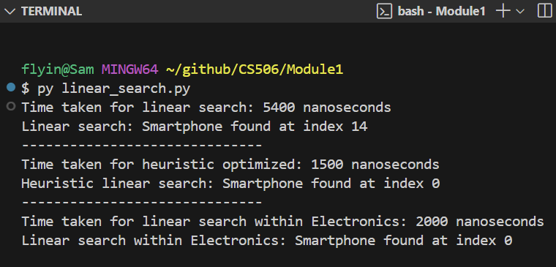

# Conclusion

Linear search, while basic, remains an essential algorithm for specific search scenarios within large online marketplace databases. Its simplicity, ease of implementation, and applicability to unsorted data make it a valuable tool despite its O(n) time complexity. Proper consideration of data structures, heuristic optimizations and external factors, such as database size and hardware capabilities, can significantly influence its performance.

# 

# References

Zybooks. (n.d.). CSC506: Design and Analysis of Algorithms. In Chapter 1.7: Heuristics. Zybooks.

Cormen, T. H., Leiserson, C. E., Rivest, R. L., & Stein, C. (2009). Introduction to Algorithms (3rd ed.). MIT Press.

Sedgewick, R., & Wayne, K. (2011). Algorithms (4th ed.). Addison-Wesley.

Knuth, D. E. (1998). The Art of Computer Programming, Volume 3: Sorting and Searching (2nd ed.). Addison-Wesley.